By:

Ali Hussain

Huma Tariq

Jiyad Khan

Abdullah Khan

Adeen Zainub

**“Role of Psychology in Daily Life Data Science and Artificial Intelligence”**



**Final Group Project**

**Role of Psychology in Daily Life Data Science and Artificial Intelligence**

**Subject: Psychology**

***Ali Hussain (19I-1701_N)***

**Huma Tariq (19I-1909_N)**

**Jiyad Khan (19I-1771_N)**

**Abdullah Shakeel (19I-1717_N)**

**Adeen Zainub (19I-1868_N)**

**Project Detail:**

**Topic:** “**Role of Psychology in Daily Life Data Science and Artificial Intelligence”**

**Submission:**

**Submitted to:** Ms. Farah Naz

**Due date:** November26’2020.

**Campus:**

NUCES FAST (Islamabad).

**Contents**

* Abstract
* Acknowledgment
* Collective Report
* Introduction
  + Psychology
  + Data Science
  + Artificial Intelligence
  + Cognitive Science
* Psychology and Daily life
* Cognitive Psychology and Data Science
* Psychology and Artificial intelligence
* Cognitive Psychology and Cognitive Science
* Theories of Psychology underlying daily life aspects
* Theories of cognitive psychology underlying AI and Data Science
* Conclusion
* References

**Abstract:**

By the grace of Almighty Allah who created our benefactor Prophet (P.B.U.H), who gave us powers and enables us to manipulate our ideas on the paper. Our main aim for doing this project is to highlight the role of psychology in the emerging fields of computer sciences Data Sciences and Artificial Intelligence, also explaining the relationship of underlying theories of psychology with Data Sciences and Artificial Intelligence.

**Acknowledgement:**

Our humble appreciation and gratitude to our worthy Ma’am Ms. Farah Naz who gave us an opportunity to do a thought provoking project, which enables us to approach and understand the realities that are commonly associated with the Psychology, Data Sciences and AI on a wider angle.

**Collective Report**

**Role of Psychology in Daily Life Data Science and Artificial Intelligence**

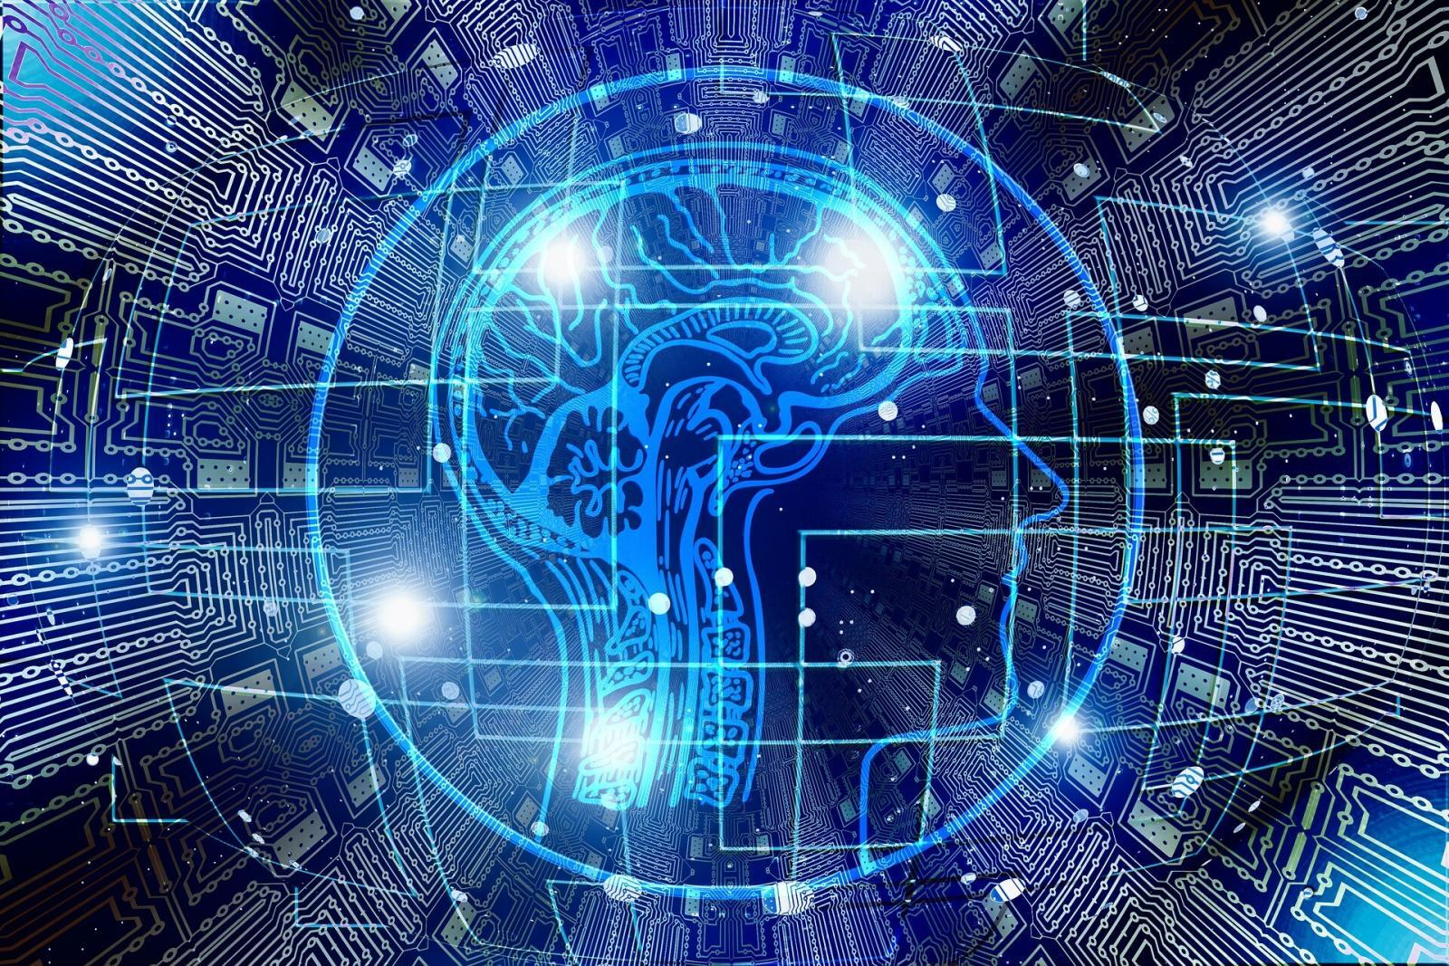

**Introduction:**

**Psychology:** [1]The word Psychology coined in 16th century from two Greek words “Psyche” meanings “Soul” and “Logos” meaning “study” thus anciently known as “Study of Soul. More precisely, it is the study of human behavior, mind and mental processes not just accompanying people’s action but also their underlying biological activities, feelings, memory, perception, reasoning and thoughts.

**Data Science[2]:** Data science is the implementation of different algorithms on scratch data to retrieve some useful patterns. Informally we can say that data science is study of data. Data can obtain from different regions, channels, and stages including PDAs, electronic media, and online business objections, clinical administrations audits. Data science incorporates the usage of AI devices, near to the utilization of assessment to open a motivation in Data. At this moment, there is a surge of improvement traveling through the field of data science considering the development in proportion of Data, advanced AI figuring, and better preparing resources. The main fields of data science are; Data Recovery, Data Analysis, Data Cleaning, Data Visualization and Machine Learning.

**Artificial Intelligence:** [3]Artificial Intelligence is consider as the capacity of an automated Computer or Commuter controlled machines or robot to perform different tasks commonly associated with humans or other animals. AI is commonly used to the undertaking of building different kind of structures improved with the scholastic cycles trivial for people, for example, the capacity to think or logical reasoning, find immensity, sum up, or machine learning (Improving or working on past experience). It has indicated that computer can be modified to finish incredibly complex tasks, discovering confirmations for mathematical theories or playing chess with remarkable capacity.

**Cognitive Science:** Cognitive science is the scientific study of complex behavior, memory, perception, learning, analytical reasoning, problem solving concept formation and thought processes. Cognitivism emphasizes the importance of thought as a basis for understanding human behavior. This behavior can be understandable by analyzing how people think. The cognitive approach has been applied in different areas of psychology including emotions, thinking, dreaming imagination etc. The cognitive science also helps us in treatment of different psychological disorders such as stress, depression etc.[4]

**Psychology and daily life:**

Psychology is the study of mind and behavior. It is the study of how a person deals in certain situations, how he makes decisions and how he copes with those problems etc. Psychology also have many uses like it helps us in time management, helps us to manage our stress, helps us in building self-confidence and in building better relations with people around us etc.

**Time Management:**  As in case of time management, there is a method/strategy called **MCII** in psychology, which helps in managing time. In this **Mental Contrasting** strategy, the scientists first make you imagine all the good things ever happened in your life, then ask about the things you want to have in the future and then make you realize all the obstacles that are going to stop you from achieving that goal of yours. Time management is one of that obstacle; this strategy makes you realize that and discloses all of your obstacles so that you can overcome them. [5](Gabriele Oettingen, 2015)



**Strengthen your relations:**

Psychology helps us in strengthening our relationships. As psychology is mainly study of behaviors so it helps in understanding the other person and their behavior even better. There are some strategies to nourish relations such as

* The expectancy effect
* Positive social support
* Empathetic listening
* Unconditional positive regard etc. [6](Ph.D., 2019)

**Coping up with stress:**Stress is actually an unpleasant feeling that produces tension. Stress can be due to painful memories, due to responsibilities that you find difficult to fulfill, due to unhealthy routine and even from little things that happen in our life such as fixed deadlines of tasks/assignments, exams etc. Stress cause headaches, heart attack, high blood pressure and depression etc. Psychology helps in dealing with stress. We can cope with our stress by always thinking positive and if the stress is due to some painful memory then stop running away from it and accept it. We can reduce our stress by sharing the problems with someone close to us, sharing problems sometimes helps in reducing stress. Make a list of things that causes stress for you then find the reason why is it causing stress and try to solve that thing.

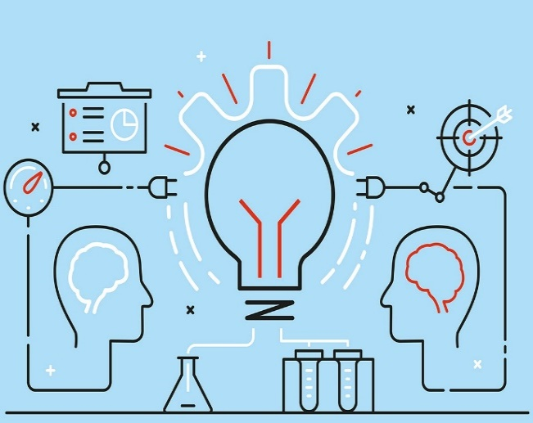**Cognitive Psychology and Data Science:**

**Cognitive Psychology** is the scientific study of internal mental processes. It includes all the mental processes like perception, thinking, attention, memory, problem solving and learning. On the other hand, **Data Science** is the study of data. It involves accessing, storing and analyzing data to effectively extract useful information. The main objective of data science is to gain information/knowledge from any type of data. To explain how data science is related to psychology we can see that the human brain is getting sharper, we can get the result of previous IQ tests given by people, can analyze and extract important information related to how a new born isgetting born with a sharper mindthan the other people in this world.We can use data to get useful information as we wanted using data science.

Computer works like human brain. Nowadays, Machine learning is allowing computers to learn from the given data. But the computers are not that much capable that they can get data itself. But in the nearer future data science can help in making such machines which will be able to learn new things itself. The machines which will be able to think and learn like human brain.

**Psychology and Artificial Intelligence:**

With the increasing advancements and developments in the fields of science and particularly artificial intelligence (AI), World has started to believe that computers can be highly smart and creative and new avenues like machine learning and AI algorithms for data structures- human concepts and practices systems also seems to be affected which opens a new opportunity to study human behavior to these changes.

Upon understanding, AI and psychology has similar fundamentality – to understand the processes. Whereas psychology focuses on understanding human mental processes, AI focuses on information processing and both these understandings have a common goal to solve problems and adapt to the environment. Therefore, based on the analogy of the Mind systems and artificial systems:

* Knowledge of the human mind can contribute to the design of more intelligent artificial system.
* The use of computational models can contribute to research on the functioning of the human mind.[7]

Artificial intelligence is somehow connected to the human psychology on the basis of the research of the network between the neurons in the human brain. These neurons are able to make the link according to your feeling, understanding and intelligence, then transfer this information by using electrical and chemical signal so that these neurons allow to configurable and accommodations learning to occur. Artificial Intelligence discover this process as a main goal and try to copy the process. Now, its scopes are gradually increase now a day. They are able to make the mechanism which have an ability to think and create like human which gives the stage and plan to the Artificial Intelligence to communicate. Sophia Robot is the prime example of the AI.

In future where artificial intelligence (AI) is extensive and widespread, psychology will play its part as an asset for helping individuals adjust to revolution and change. Behavioral psychology that deals with learning and accepting a new change comes critical when AI functions enter the daily lives of humans – human mind will have to condition itself to the new theories, new systems and new experiments and techniques that proves AI to be embedded as the behavioral modifications in daily lives affecting the Activities, **Interests**, and **Opinions** (AIO) (behavioral psychology) of humans.

However, Human mind acceptance to AI is still a question and a possible challenge. AI could be well accepted or quickly rejected by humans. The relationship of technology and human psychology and behavior comes with usage and learning curve. AI may require humans to acquaint themselves more with technology, machines and computers in order to be able to interface. There may be cultural differences in willingness to accept AI.

**Cognitive Psychology and Cognitive Science**

Cognitive psychology is the “scientific study of the mind as an information processor”. [8]Just as the information system of a computer with input, processing and output, human mind also works in the same pattern. The utilization of the PC as an apparatus for suspecting how the human’s mind handles the data was assumed by the scientific cognitive psychologists as the prototype how human feeling and view operate and that it’s when PC analogies of data science were presented.

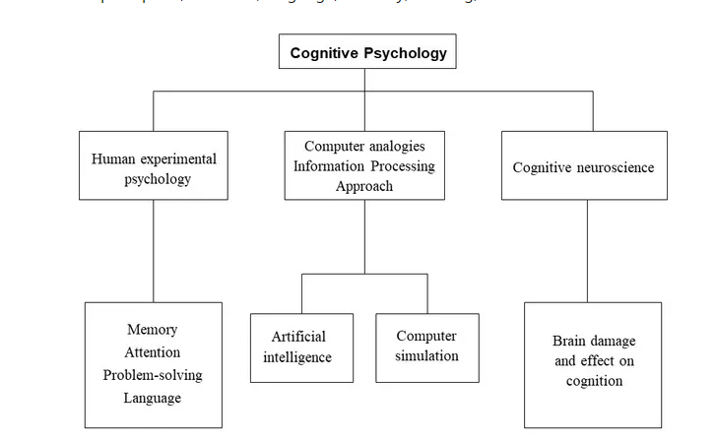

With the increasing trends of computer processing information, and introduction of artificial intelligence and machine learning in our daily lives, the emphasis on learning of human behaviors and human learning shifted to machine learning and how machines and intelligent systems process data, change and information.

**Cognitive science** is the study of mind and intelligence, both of human mind and creativity as well as computer systems. It’s interdisciplinary on psychology and computer science.As there are many question that has been evolving around into this scope. These questions are:

* How the people do recognize the thing around them through their sense?
* How they are able to learn a new skill?
* How they are able to understand one another?
* How they are able to act in a good time in a changing world?

Most researchers of the cognitive science, tackling these issues, predicted that the mind of the human is some kind of the arithmetic unit or information device or calculating device which contain different kind of design which have different kind of scenario.

Both Cognitive Psychology and Cognitive Science are the field that are working on different minds of the different human and make them better. Cognitive Psychology try to study on the human with feeling so that it would help to work on the human’s thinking to make their behavior’s better. Cognitive Science studying on the different parts of the human’s mind so that they analyze at what because they give a particular reaction. This field is more than research based field.

**Theories of Psychology underlying daily life aspects:**

In psychology, theories are provided to understand human thoughts, ideas and their behaviors. As time passes, different psychologist gave different theories to explain psychology and understand human thought and their behavior on the basis of their theories. In the history of psychology different theories plays important role in specific manner but all in end they are categorizes in few known theories like

* Psychoanalysis
* Behaviorism
* Cognitivism
* Humanism
* Development theory
* Emergence theory
* Spearman’s two factor theory
* Thurston multiple factor theory
* Psycho-analytical theory

Apart from these theories, some other theories are also play a vital role when we talk about psychology.

As psychology is the study of human thought and action. Through psychological theories it is easy to understand human action and thoughts while communication. Psychological theory such as behaviorism can also help us to understand human behavior in different circumstances. By using different aspect of psychological theories, we can understand human action and gesture that make even communication easier in particular manner. Clinical psychology can help us to understand people behavior and point out difference in behavior of people in different circumstances. Psychological theory like personality can also help us to understand people’s pattern of thinking and feeling, through this, we can judge the personality of people. According to psychological research psychology can build quality like leadership in a person. Psychology improve communication skills of people whether the communication is held between small group of participants or it is a public speaking by understanding others behavior and thoughts. Psychology can also help to understand people as well own emotion because emotion play a vital role in everyone life. Folk with psychological ideas and thought can understand other easily and make relationship in a good manner. Folks can be responsible by knowing their responsibility can make their daily life easier.

**Theories of cognitive psychology underlying artificial intelligence and Data Science:**

As its already explained that cognitive psychology deal with the human mind and process like problem solving, thinking learning perception etc. The main focus of the cognitive psychology is that how our brain receives and store information and how process and gave result when needed.

On the other hand, Data science deal with the large amount of data. It also includes storing, retrieving and analysis of large amount of data. Todays every large company like Google, Facebook, and Amazon are dealing with large amount of data and they need professionally trained data scientist with a lot of skills. Cognitive psychology plays a very important role in mental health and mental behavior while dealing with such a large amount of data. As cognitive psychology deal with process like decision making and problem solving. When it comes to solve the problems occur during analysis of large amount of data, folks with psychological mind can gave a good result because they can manage their mental behavior. Behaviorism is a school of thought of psychology and play an important role when talk about data science while cognitivism plays a very important role in artificial intelligence.

Goal of artificial intelligence is to model human intelligence, natural language processing (communication between model and human), learning and problem solving. Todays the field of artificial intelligence is growing day by day. Cognitive psychology can help a lot in field of artificial intelligence. Cognitive psychology gave a route to model this onto computer for example natural language processing. According to cognitive psychology brain is processing device and article intelligence accept this idea. When it comes to artificial intelligence the model can store and process information and gave this information to user when needed while on the other hand, human mind sometime can’t recall the information after a specific period of time. That’s how cognitive psychology help artificial intelligence.

**Conclusion:**

Psychology being a multifaceted discipline which covers various aspects of our concern. It plays a key role in understanding people’s behavior and mental operation which refers to understand events, complex problems and modern world needs as it covers the convergence of applied, instructive, and hypothetical science.

Discernment of human thoughts and actions eventually helps in designing things accordingly. When the problem is known, it’s easy to cure it. Psychology helps in understanding the problem, it gets us to the root cause which is underlying thought processing of human mind. While designing a product we first have to look if it’s useful and how much demand it has in the market and for that we have to first read the human minds. By reading human minds we get to know its interest pattern, things that attracts the buyer, through this way we can easily excel in market as well. As far as it’s concerned with data science, we have a lot of data but we have to retrieve the useful content out of it. With regards to tackle the issues happen during examination of enormous measure of information, psychology helps in getting a more effective and positive outcome. In the same way while making an artificially intelligent machine we keep in view the behavior of humans and design our machine accordingly. Just like artificially intelligent Sofia. Its creation is done keeping in view the human behavior that how a person would react in a certain situation .Keeping in view the reflexes a human can show in a certain condition, it’s designed to give response accordingly.

Apart from the role of psychology in the formation of machines, psychology also helps a person to understand themselves well. When the person know himself better he can manage time and things more efficiently. When one gets to know the root cause of chaos in him he can easily put the bug out rather than wasting time in finding bug in thousand other things. This way not only we save the time .It also help us to have less stress and our work efficiency is boosted up to 100 times.

Hence we can conclude it with a quote:

**“What you think, you become**

**What you feel, you attract**

**What you imagine, you create”**

**-BUDDHA**

# References

1. Kendra, Cherry. June 10 2020. Very Well Mind, What is Psychology, [online] Available at :<<https://www.verywellmind.com/psychology-4014660>> [Assessed 05 November 2020]
2. Caroline, Benton. August 27 2019.Investopedia,Data Science , [online] Available at :

   < <https://www.investopedia.com/terms/d/data-science.asp> > [Assessed 05 November 2020]
3. Nick Heath, February 12, 2018, ZD Net, What is AI, Everything you wanted to know about AI, [online] Available at :< <https://www.zdnet.com/article/what-is-ai-everything-you-need-to-know-about-artificial-intelligence/>> [Assessed 05 November 2020]
4. Very Well Mind, 2020. *How psychology can improve your life*. [online] Available at:< <https://www.verywellmind.com/ways-psychology-can-help-live-a-better-life-2795615>> [Assessed 10 November 2020]
5. Gabriele Oettingen, H. B. K. K. B. G. a. P. M. G., 2015. Self-regulation of time management: mental contrasting with implementation intentions. *European Journal of Social Psychology,* p. 42.
6. Ph.D., R. E. R., 2019. *7 Psychological Strategies to Strengthen Relationships.* [Online]   
   Available at: https://www.psychologytoday.com/us/blog/cutting-edge-leadership/201901/7-psychological-strategies-strengthen-relationships
7. MORENO, R. A., 2017. *Psicobotica.* [Online]   
   Available at: https://www.psicobotica.com/en/2020/06/06/artificial-intelligence-and-psychology/  
   [Accessed 02 11 2020].
8. McLeod, S., 2020. *Simply Psychology.* [Online]   
   Available at: https://www.simplypsychology.org/cognitive.html  
   [Accessed 5 11 2020].